**Enterprise Resource Planning**

**Training User Manual**

**VERSION 12.0.0**

**INVENTORY**

* **Inventory**
  + **Receive Adjustment**
  + **Issue Adjustment**
  + **Receive Entry**
  + **GL Transfer**
  + **Reports**

# Receive Adjustment

## Check stock availability

|  |  |
| --- | --- |
| **Step 1** | Open System **>** Inventory **>** Receive Adjustment |
| **Step 2** | Select *Item Code* from side list or write the Code in the *Item Code* field |
| **Step 3** | Click show |
| **Result** | Requested product checked for availability and will show the stock status in the bottom list. |

## Add Other Receive

|  |  |
| --- | --- |
| **Step 1** | Open System **>** Inventory **>** Receive Adjustment |
| **Step 2** | Select the *Item Code*, *Supplier ID*, *Serial* from the lists |
| **Step 3** | Write the price, qty & unit etc. |
| **Step 4** | Click **Add** |
| **Result** | Requested product added to Receive. |

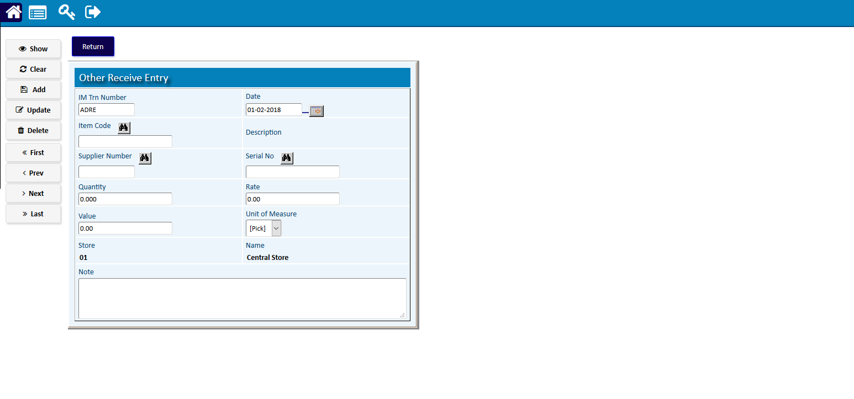

# Issue Adjustment

## Check Issue availability

|  |  |
| --- | --- |
| **Step 1** | Open System **>** Inventory **>** Issue Adjustment |
| **Step 2** | Select *Item Code* from side list or write the Code in the *Item Code* field |
| **Step 3** | Click show |
| **Result** | Requested product checked for availability and will show the stock status in the bottom list. |

## Issue Entry

|  |  |
| --- | --- |
| **Step 1** | Open System **>** Inventory **>** Issue Adjustment |
| **Step 2** | Select the *Item Code*, *Supplier ID*, *Serial* from the lists |
| **Step 3** | Write the price, qty & unit etc. |
| **Step 4** | Click **Add** |
| **Result** | Requested product added to Receive. |

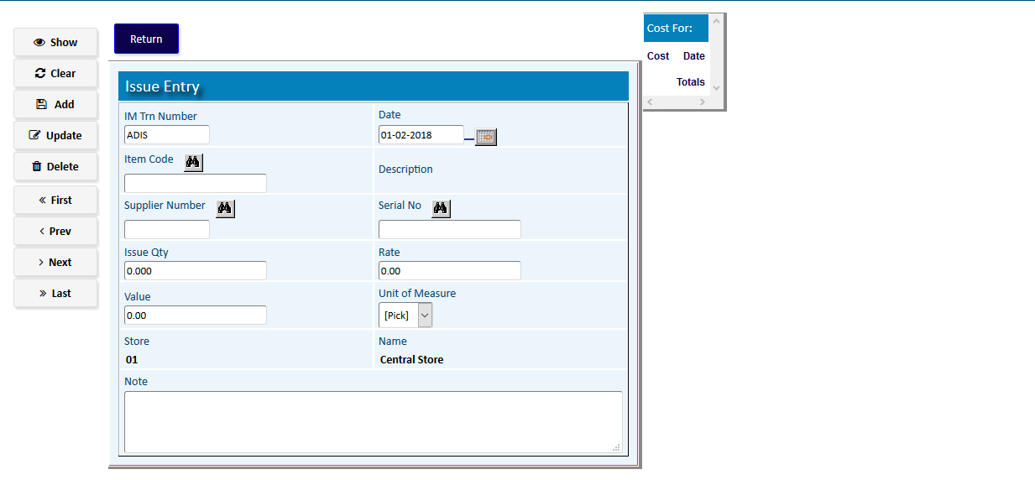

# Receive Entry

## Check Receive availability

|  |  |
| --- | --- |
| **Step 1** | Open System **>** Inventory **>** Receive Entry |
| **Step 2** | Select *Item Code* from side list or write the Code in the *Item Code* field |
| **Step 3** | Click show |
| **Result** | Requested product checked for availability and will show the stock status in the bottom list. |

## Add Receive

|  |  |
| --- | --- |
| **Step 1** | Open System **>** Inventory **>** Receive Adjustment |
| **Step 2** | Select the *Item Code*, *Supplier ID*, *Serial* from the lists |
| **Step 3** | Write the price, qty & unit etc. |
| **Step 4** | Click **Add** |
| **Result** | Requested product added to Receive. |

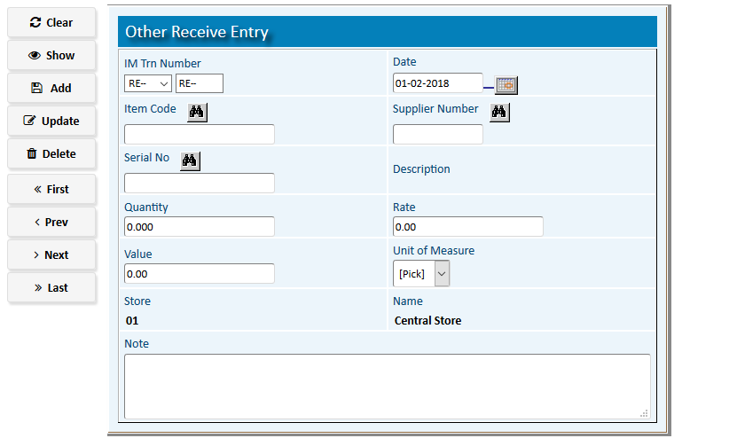

# GL Transfer

## Check Receive availability

|  |  |
| --- | --- |
| **Step 1** | Open System **>** Inventory **>** GL Tranfer |
| **Step 2** | Select first Date and to date |
| **Step 3** | Pick the Transaction Code |
| **Step 4** | Press the button *Final Run* |

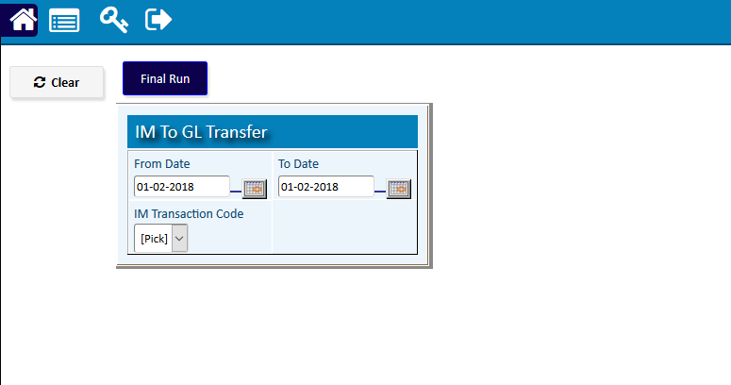

# Reports